Text Parser -> Parses a txt file removing the whitespace and replacing the ‘Special Character’ with a ‘,’ comma. Prints to terminal. Copy and paste said terminal to create a CSV file.

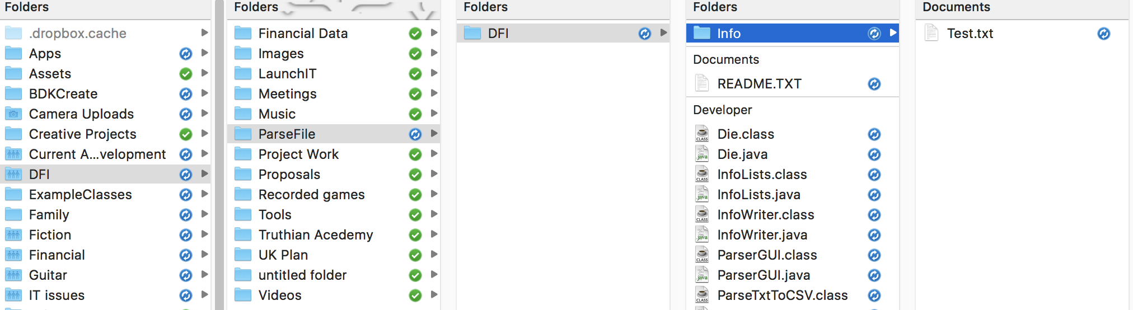Directions:

Find the BlueJ package in DFI/ParseFile/DFI

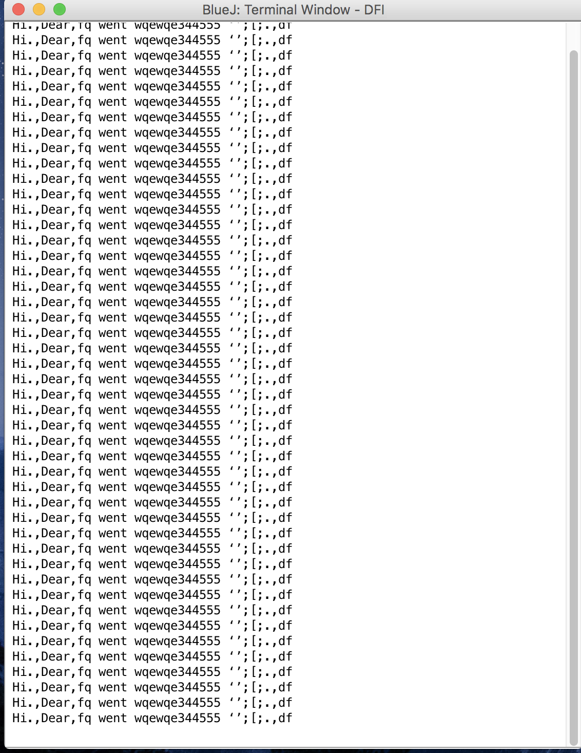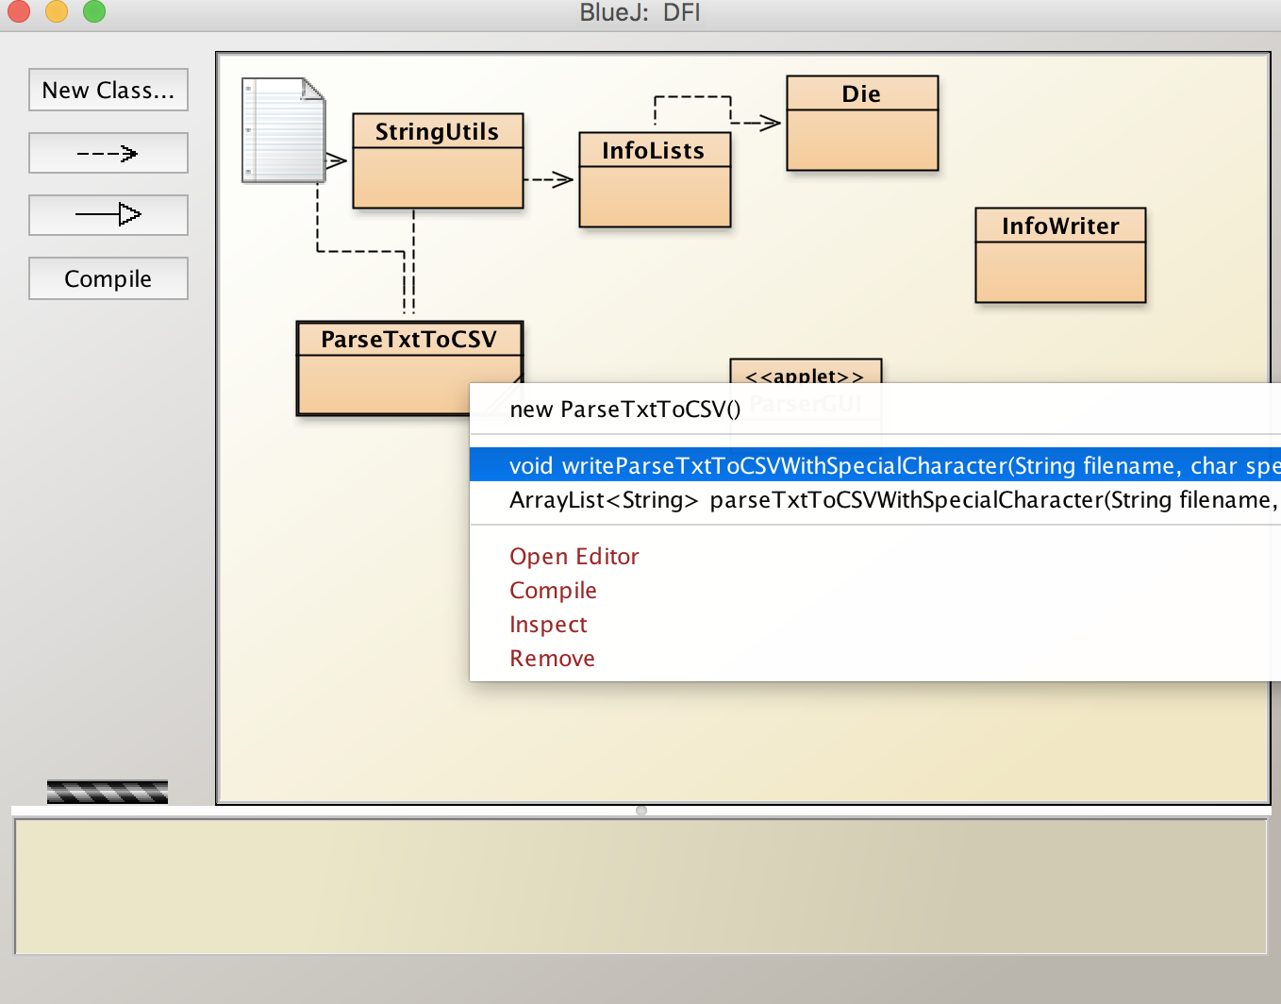Place you .txt file in the INFO Folder

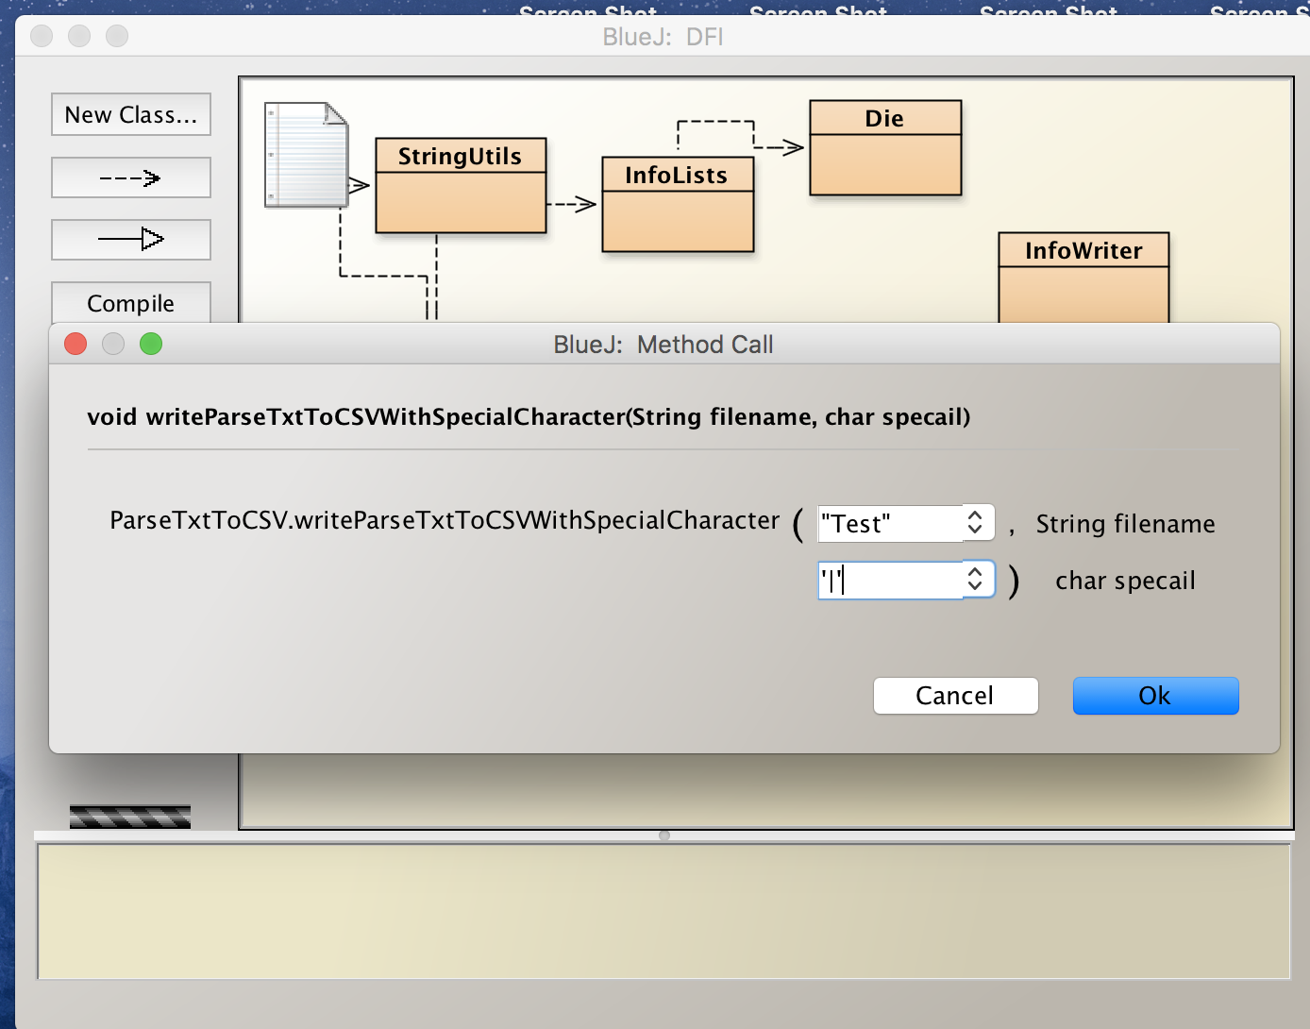Click on highlighted Method to start process

Output in terminal

Copy and paste into a text editor and save file as CSV then open in Excel

Enter file name with “” double quotes it IS CASE SENSITIVE

Enter special Charicter with ‘|’ single quotes and only enter one char or you will get errors